**Phase 3: Data Modeling & Relationships**

1. **Custom Objects**

* 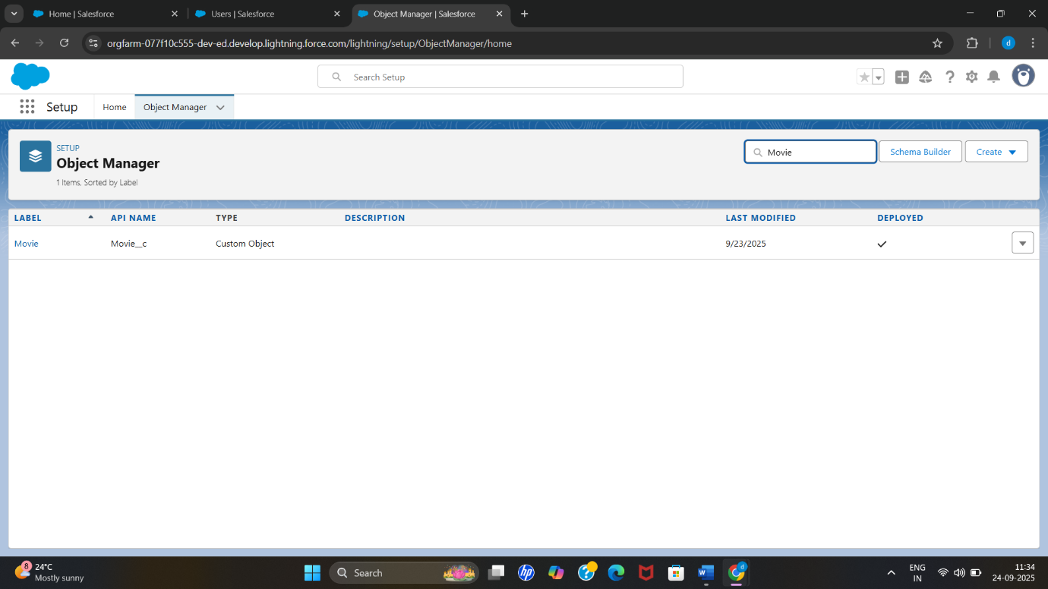**Movie__c** – Holds details of each movie such as title, type/genre, duration and audience rating.
* **Show__c** – Stores information about each movie show, including date, time and available seats, and links to its Movie.

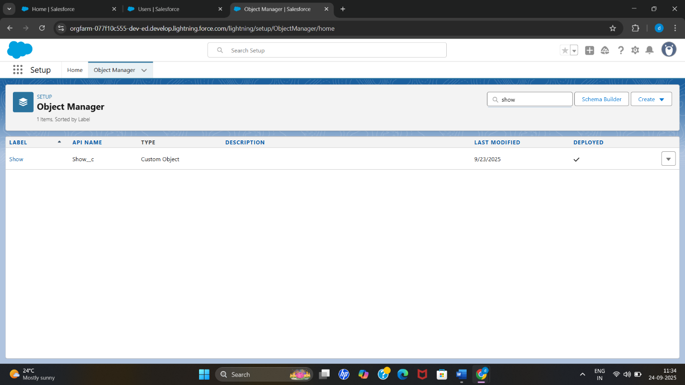

* **Booking__c** – Records every ticket booking, the number of seats booked and booking

status, and is related to a specific Show and Customer.

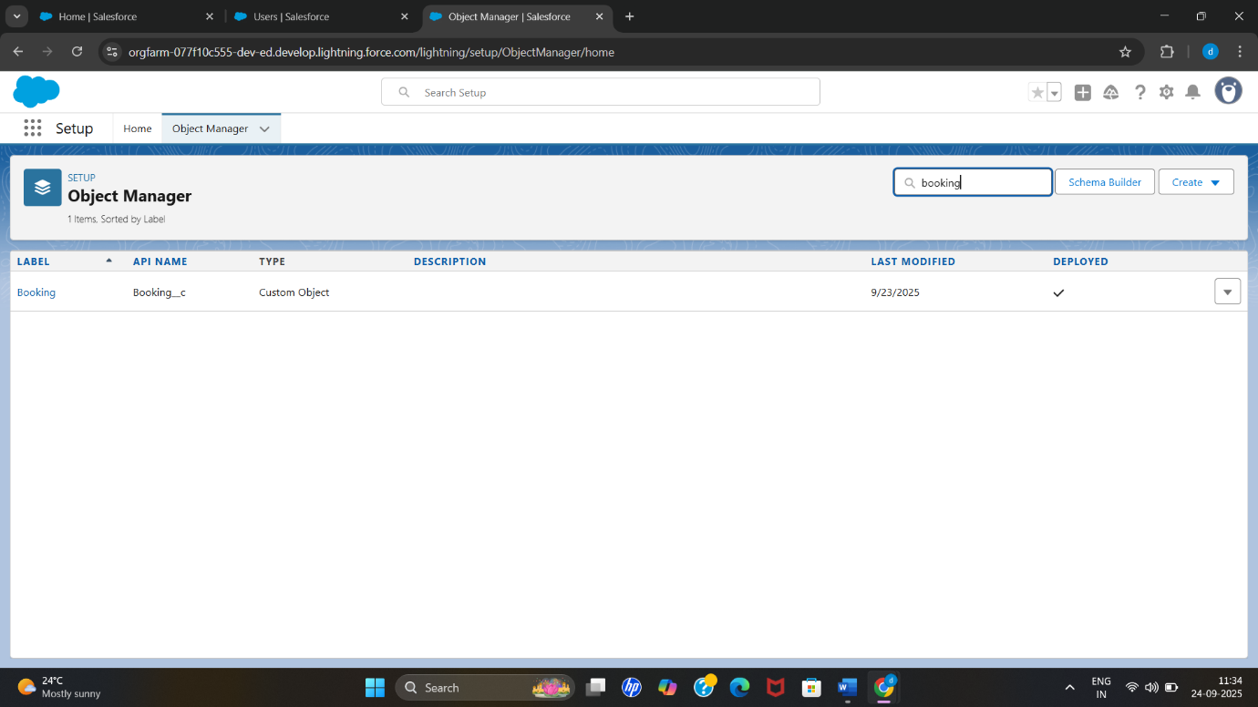

* 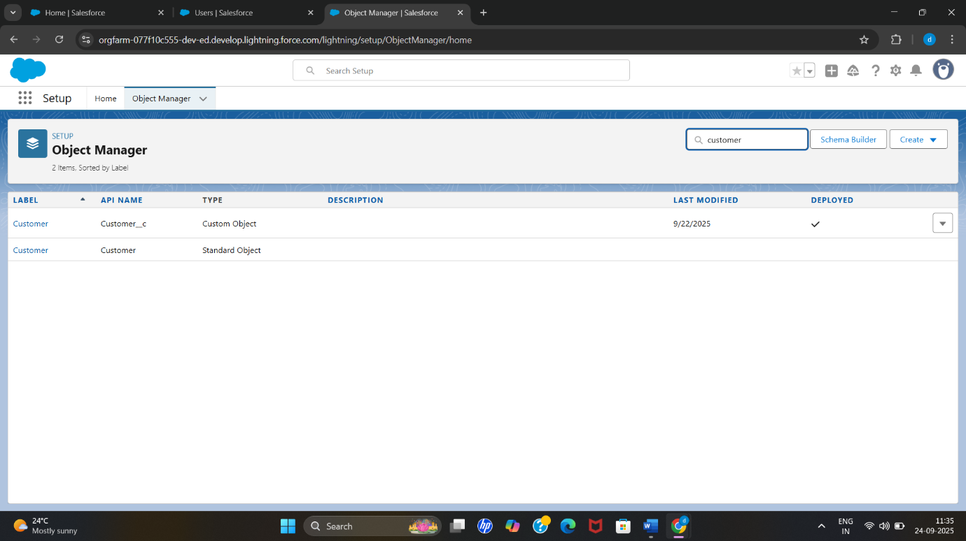**Customer__c** – Maintains customer details like name, contact info and loyalty points; used to track bookings and promotions.

1. **Fields and Relationships**
2. **Movie__c** – Stores details of each movie.

* **Fields:** Movie Name (Text), Genre (Picklist), Duration (Number/Time), Rating (Picklist), Release Date (Date).
* **Relationships:** Lookup from **Show__c** → **Movie__c** (each show is linked to a specific movie).

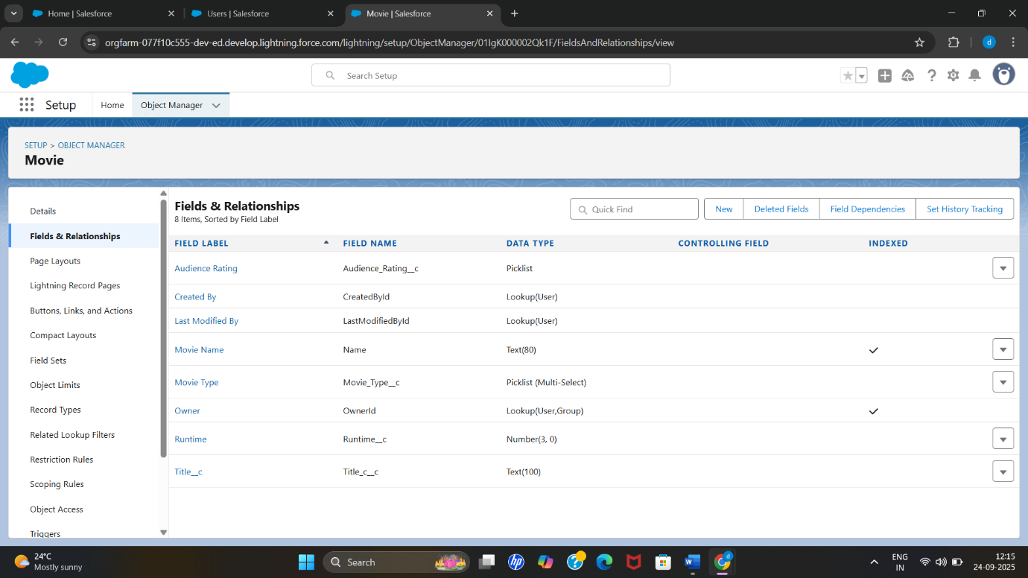

1. **Show__c** – Represents each screening.

* **Fields:** Show Name (Auto Number/Text), Show Date (Date), Show Time (Time), Available Seats (Number), Price (Currency).
* 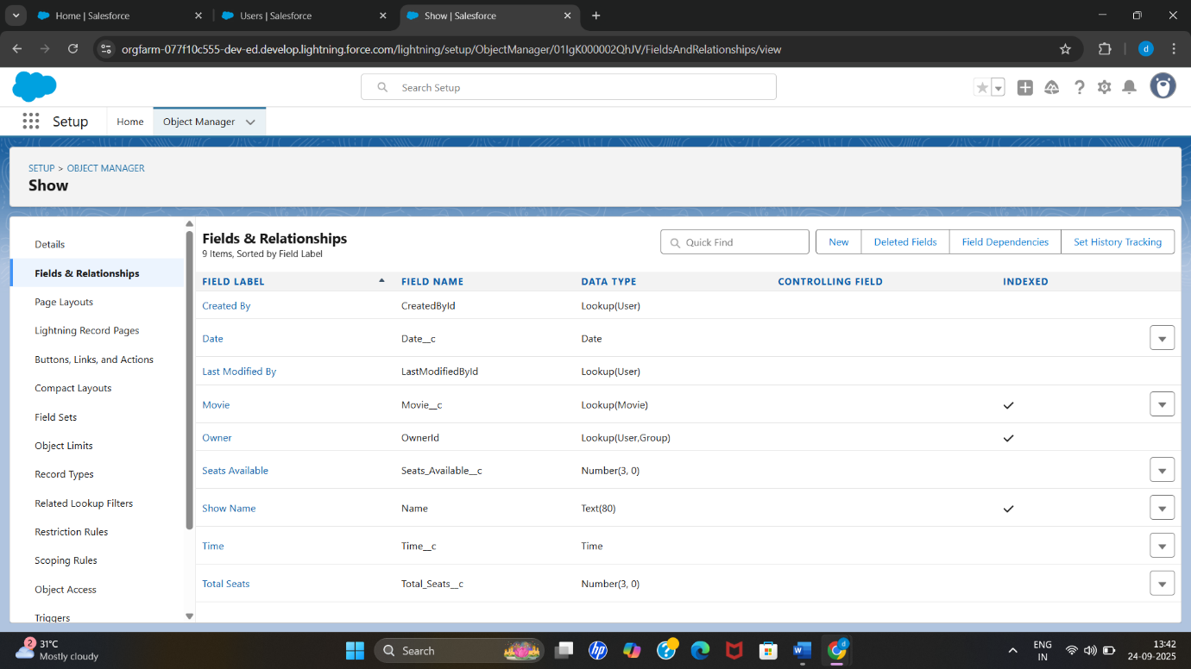**Relationships:** Lookup to **Movie__c** (which movie is being shown); Lookup from **Booking__c** → **Show__c** (each booking is tied to a show).

1. **Booking__c** – Captures ticket bookings.

* **Fields:** Booking Number (Auto Number), Seats Booked (Number), Total Amount (Currency), Booking Date (Date/Time), Status (Picklist: Confirmed/Cancelled).
* **Relationships:** Lookup to **Show__c** (show being booked) and Lookup to **Customer__c** (customer making the booking).

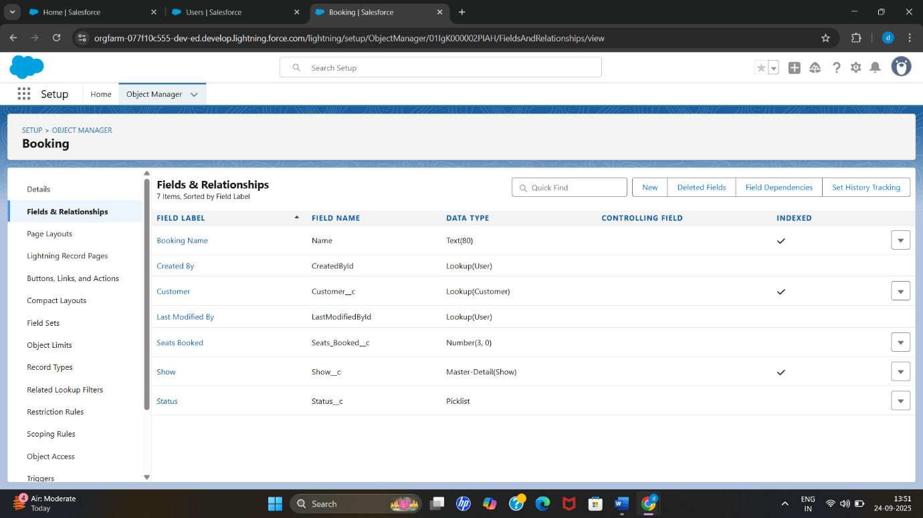

1. **Customer__c** – Stores customer details and loyalty information.

* **Fields:** Customer Name (Text), Email (Email), Phone (Phone), Loyalty Points (Number), Type (Picklist: VIP / Regular).
* **Relationships:** Lookup from **Booking__c** → **Customer__c** (each booking belongs to a customer).

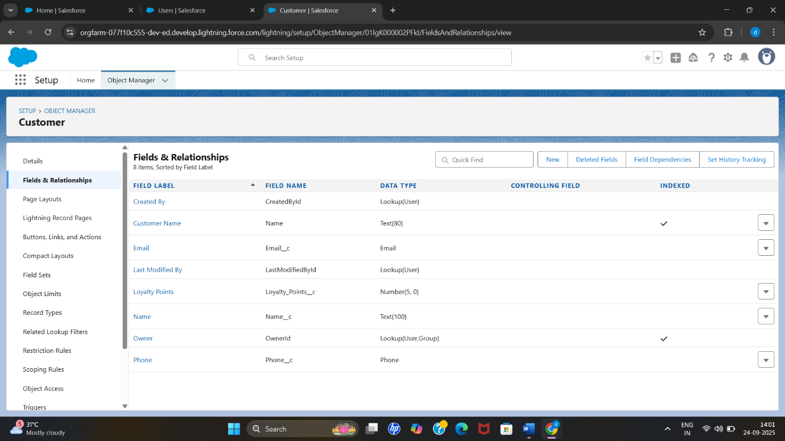

1. **Record Types**

* In the Customer__c custom object, two record types were implemented to handle different categories of customers:
* **VIP Customer** – Designed for high-value customers who get special services. This record type displays extra details such as Loyalty Points, Booking History, and Premium Offers. It is linked to the Customer Layout – VIP page layout, which highlights these additional fields.
* 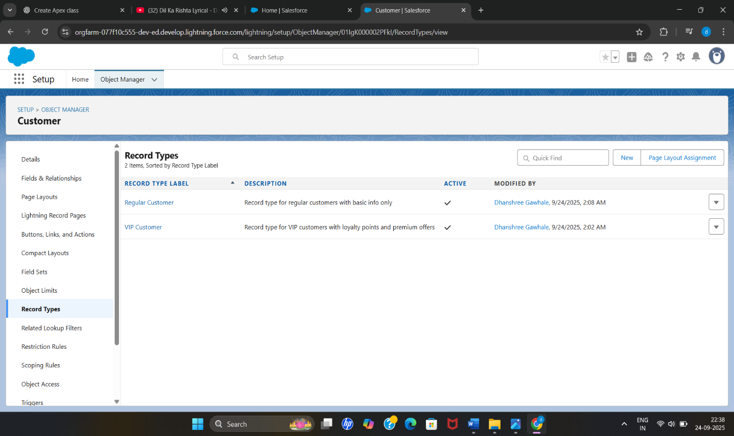**Regular Customer** – Meant for standard customers with only the basic information such as Name, Contact Details, and Ticket Booking Details. It uses the Customer Layout – Regular page layout, which hides VIP-specific fields.

1. **Page Layouts**

support the two record types on Customer__c, two custom page layouts were created:

* **Customer Layout** – VIP is assigned to the VIP Customer record type. It displays fields such as Loyalty Points, Premium Offers, and Booking History, providing theater staff with all the relevant information needed to manage high-value customers effectively.
* **Customer Layout** – Regular is assigned to the Regular Customer record type. It displays only basic customer information and standard booking details, simplifying the interface for standard customers by hiding VIP-specific fields.

